SERVER:-

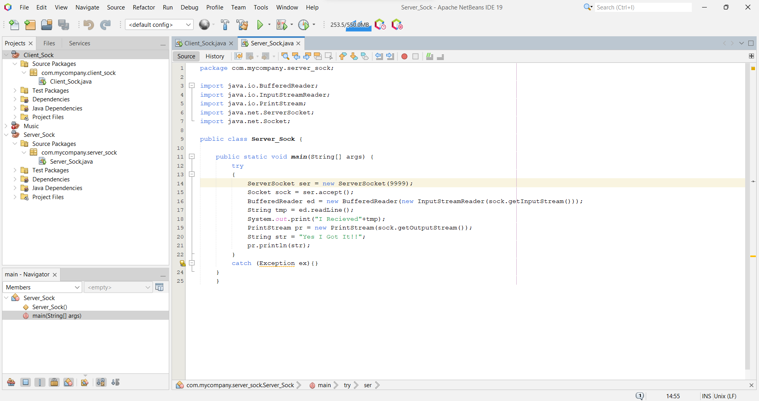

Client:-

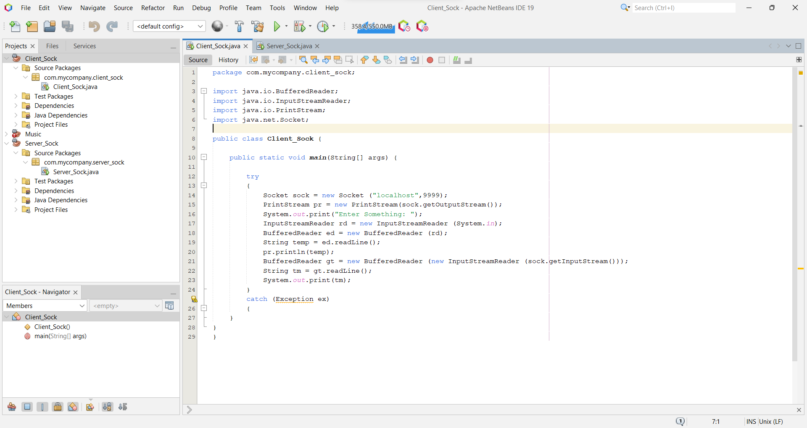

Output :-

1:- From Client

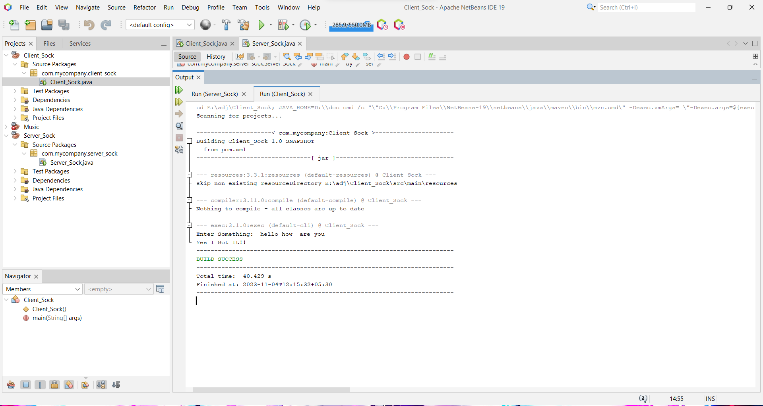

2:- From Server

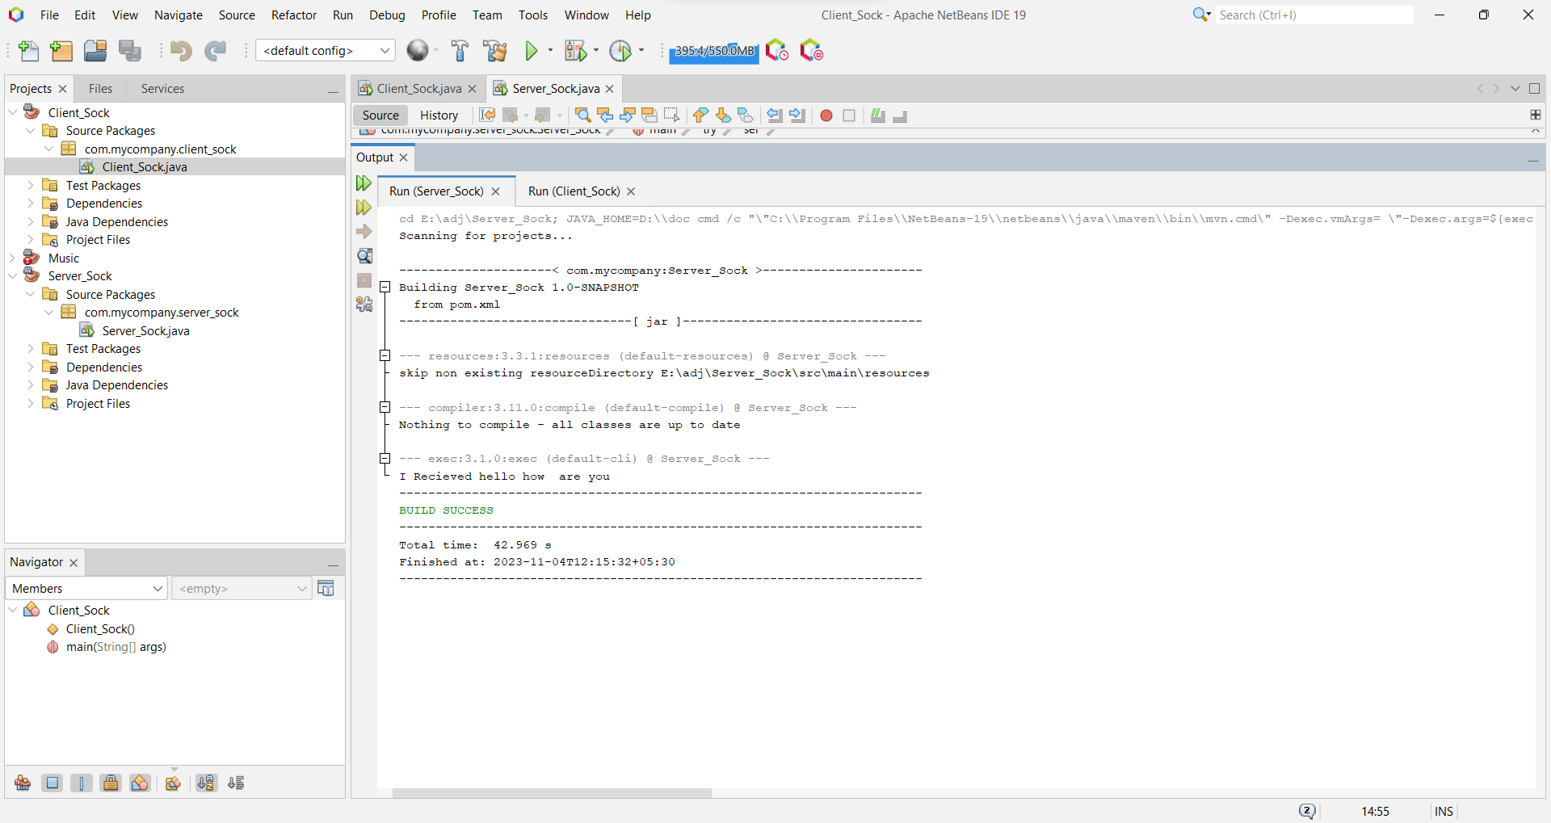

Client side code:-

File Name:- Client_Sock

package com.mycompany.client_sock;

import java.io.BufferedReader;

import java.io.InputStreamReader;

import java.io.PrintStream;

import java.net.Socket;

public class Client_Sock {

public static void main(String[] args) {

try

{

Socket sock = new Socket ("localhost",9999);

PrintStream pr = new PrintStream(sock.getOutputStream());

System.out.print("Enter Something: ");

InputStreamReader rd = new InputStreamReader (System.in);

BufferedReader ed = new BufferedReader (rd);

String temp = ed.readLine();

pr.println(temp);

BufferedReader gt = new BufferedReader (new InputStreamReader (sock.getInputStream()));

String tm = gt.readLine();

System.out.print(tm);

}

catch (Exception ex)

{

}

}

}

Server Side Code:-

File name:- Server_Sock

package com.mycompany.server_sock;

import java.io.BufferedReader;

import java.io.InputStreamReader;

import java.io.PrintStream;

import java.net.ServerSocket;

import java.net.Socket;

public class Server_Sock {

public static void main(String[] args) {

try

{

ServerSocket ser = new ServerSocket(9999);

Socket sock = ser.accept();

BufferedReader ed = new BufferedReader(new InputStreamReader(sock.getInputStream()));

String tmp = ed.readLine();

System.out.print("I Recieved"+tmp);

PrintStream pr = new PrintStream(sock.getOutputStream());

String str = "Yes I Got It!!";

pr.println(str);

}

catch (Exception ex){}

}

}